**Student Behavior and gender related to grades**

Behavior and gender is a social construct that varies across cultures and has been disputed since antiquity , We will do some statistics to know more about that

Several Aspects related to student Behavior and gender related to grades would be discussed

**This is the distribution of gender in our data**

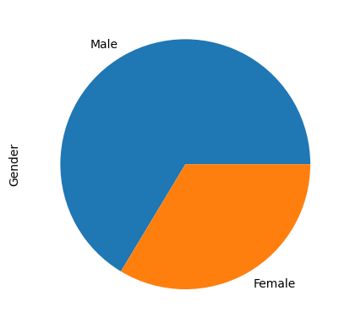

The male percentage nearly 66% of the sample while females is 34% of the sample

**1-Relation between grades and gender**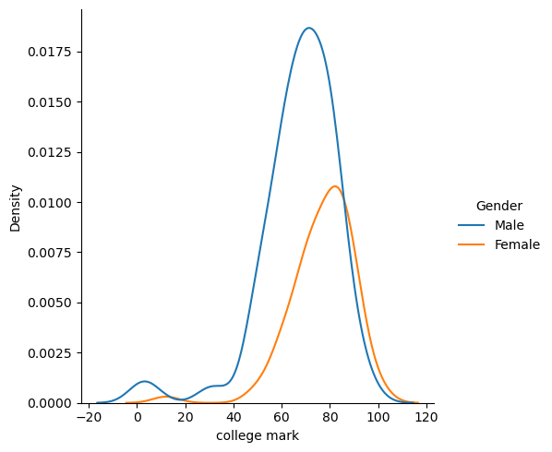

|  |
| --- |

#### **Reject null hypothesis( There is no relation between gender and grades )**

The Independent t-test results are significant (p-value very very small)!

we can reject **the null hypothesis** in support of **the alternative hypothesis.**

this relation between gender & grade

**Conclusion:**

The grades of Female is higher than grades of Male in general

**2-Do you like your Degree?**

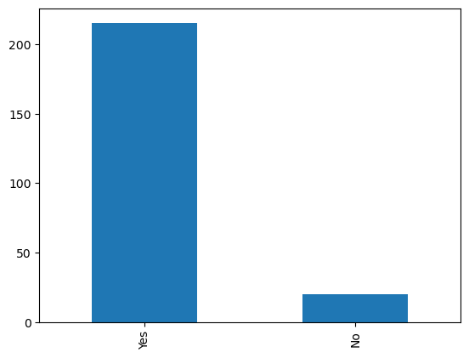

| Freq |
| --- |

In the Sample most of students like their degree but Is this has effect on grades ?

by applying linear regression

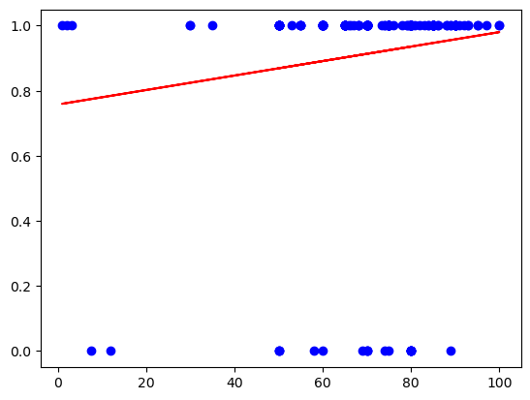

#### **Slight direct relationship between students’ grades and like your degree is hard (since the slope is quite small) (grades no longer depend on do you like degree?).**

Conclusion:

#### **Accept null hypothesis(that there is no relation)**

The Independent t-test results are significant (p-value Slightly large than 0.05)!

we can accept **the null hypothesis** in favor of **the alternative hypothesis.**

this relation between grades & do you like your degree

.

**3-Stress level**

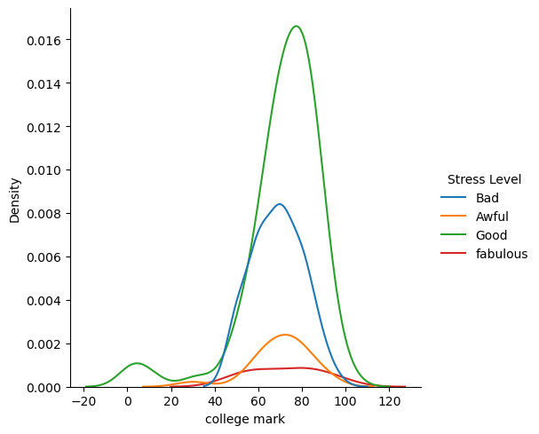

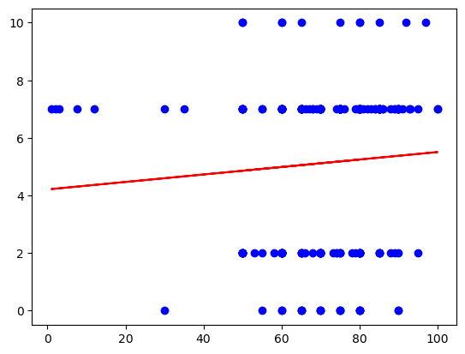

**Conclusion:**

#### weak direct relationship between students’ grades and stress level is hard (since the slope is quite small) (grades no longer depend on stress level).[¶](http://localhost:8888/notebooks/Desktop/Traits.ipynb#weak-direct-relationship-between-students%E2%80%99-grades-and-stress-level-is-hard-(since-the-slope-is-quite-small)-(grades-no-longer-depend-on-stress-level).)

There is no relation between stress level and college grades

**4-Social media and video time**

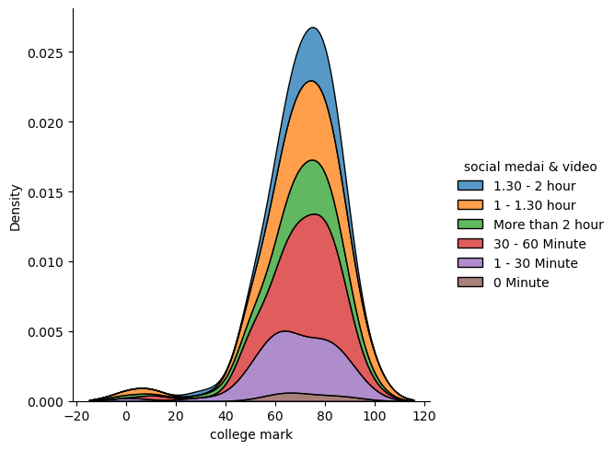

Ttest_indResult(statistic=0.4243962883001781, pvalue=0.6717808328157719)

#### **Accept null hypothesis**

The Independent t-test results are significant (p-value large than 0.05)!

we can accept **the null hypothesis** in favour of **the alternative hypothesis.**

this relation between grades & social medai & video

Conclusion:

There is no relation between social media time and grade

**Conclusions**

1-Gender has effect on grades Female grades larger than Male grades.

2-Whether you like your degree or not it hasn’t significant effect on Students grades.

3-Stress level has no direct relation on Students grades.

4-Social media and video time doesn’t affect Students grades.